Prompt: What is something totally inconsequential that you have a strong opinion about (I have a lot of strong opinions on a lot of inconsequential things so I’m doing this in the way I only know how – in the style of the Anthropocene reviewed).

The Chapters John Cut From The Anthropocene, Reviewed

or the ones he should’ve added

My favorite book/podcast/piece-of-media of all time is *The Anthropocene Reviewed,* by John Green. I make this no secret. I have a signed copy of the book1, which I carry in my backpack to school at nearly all times for easy access, I (re)listen to the podcast while driving to school each morning, and I own a copy of the audiobook (for audio-exclusive chapters). I can literally say I would not be at MIT without this work2. In the collection of essays, Green reviews varying inconsequential aspects of The Anthropocene on a five star scale – from Googling Strangers, to Canadian geese, to Diet Dr. Pepper, all ultimately reflecting on what it means to be human.

But I think he missed a few key reviews. Ones that I deeply believe, should have been reviewed. So, I will do my best to amend that. Here are the three lost reviews, written by yours truly.

1. Cheese Curd Pizza:

Fried cheese curds (henceforth known simply as cheese curds) are a delicacy in the Upper Midwest, where I’m from. They are ubiquitous – at nearly every restaurant as an appetizer or alternate side. Beyond that, they’re good – like really good. It’s hard to describe to someone who has never had one, but cheese curds are a delicious gooey blob of cheese, and batter, all merging into a wonderful flavor. Pairing the right dipping sauce can elevate the experience even more (my personal favorite is the jalapeno blackberry jam at one of the countless State Fair vendors selling cheese curds).



I’ve grown up with cheese curds my whole life, and up until very recently, believed them to be as ubiquitous as the french-fry. So, I was a tad shocked when I started to meet pre-frosh friends at MIT and learned that fried cheese curds just flat out aren’t a thing outside of Minnesota and Wisconsin. Like what? This low-key collapsed my entire worldview – I have been in a bubble of my home state for 18 years of my life and if I didn’t know cheese curds weren’t a thing, what about everything else?? Existential crisis aside, I now have taken new pride in the humble but mighty cheese curd.

That was until this summer, when at a graduation party, I discovered that someone was putting these on pizzas. To put it kindly, my home state of Minnesota is not quite exactly known for making good pizzas. Like, we are known for cutting pizza into squares, and occasionally topping them with [dill pickles](https://www.fox9.com/news/minnesota-state-fair-whats-the-big-dill-about-pickle-pizza) and [meatballs](https://mspmag.com/locations/Black-Sheep-Pizza-%282%29/). If it hadn’t been for Nino’s (one of the only NY-style pizza shops in MN) being right next to my school I don’t think I’d ever even eat pizza here. This summer I was at a graduation party and was slightly revolted to learn that there was such a thing as hot-honey cheese curd pizza. This is quite possibly the most Minnesotan combination of foods ever: something that shouldn’t go on pizza, and putting that on pizza.

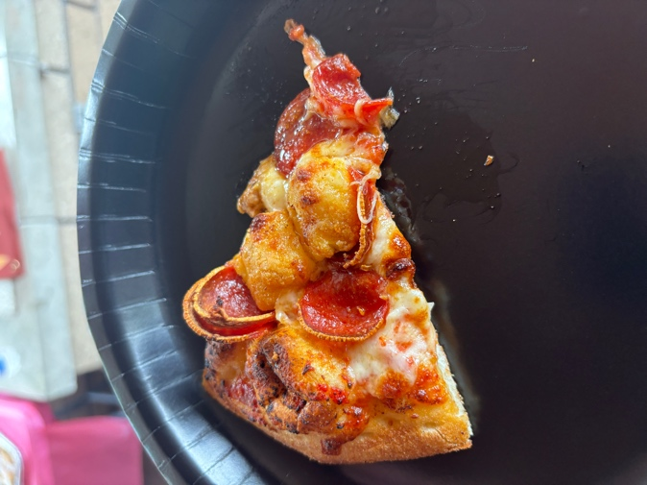

In an embrace of Minnesota tradition, however, I had to try it. And like it wasn’t bad. I still question the choices of those who cooked up the recipe, but it turns out greasy fried cheese goes well on greasy fried cheese bread. Who would’ve thought? It also reminds me of home, that even though we may be a little weird, my home state is unique in its own way, and that I should celebrate that.

I give cheese curd pizza 3 stars.

1. The Boy and the Heron:

My experience watching the latest Studio Ghibli film is intrinsically tied with my experience receiving my Early Action MIT decision. It was Saturday, December 16th, and to destress from the admissions decisions releasing that weekend, my friends decided to watch The Boy and the Heron to destress.

We scheduled a showing that started at 11:30am central time. Our admissions decisions had been slowly rolling out across the weekend, and I would be the last one to receive a decision. At 11:16am. Fourteen minutes before the movie started. Just as planned.

While most people want to receive their decisions while in a quiet place alone (which is a totally valid way to receive admissions decisions), I wanted to be amongst my friends when receiving decisions – of the 5 decisions I opened, only one of them was opened in my house. For me, I made this decision for two reasons: I felt comfortable with being vulnerable around them; and I wanted to be able to celebrate/commiserate my who I loved. I am glad I thought about my decision opening plan well in advanced and reflect on where I wanted to be. Specifically in the case of my MIT decision, we decided to see the movie so close to the decision time, so that I would be able to re-level my emotions – accepted or not.

We were running a bit late, and MIT released the decisions a bit early, so I ended up actually seeing my decision while my carpool was still driving – and I naturally screamed in shock, causing my friend to almost swerve off the road3. We got to the theater, rushed to get popcorn, and then watched the film.

Did I mention how good it was? The movie is like, really, really good. The visuals are stunning, the soundtrack is beautiful, and the themes exploring grief and creation were moving, especially surrounding my experiences over the college application process. It is one of Studio Ghibli’s best works. I completely forgot about my recent admission into MIT, and instead melted into the fantasy world written for Mahito. I cried. Multiple times. I could say so much about the movie, but also, what hasn’t already been said? If you haven’t watched this movie yet, stop reading this blog and see it NOW4.

If I had to give one critique of the movie (and is this even really a critique if it is the same for all Ghibli films?), is that at times the plot did not make a ton of sense, although that is to be expected and par for the course. Otherwise, The Boy and the Heron was by far my favorite movie that I saw in 2023.

I give The Boy and the Heron 4.5 stars.

1. Left-Handed Scissors:

As a left-handed person born into a world designed for right-handed people, some things just don’t always fit. Using scissors, for example, always leaves a throbbing indentation on my thumb, which is like, kinda uncomfortable?? You can see in the photo that it doesn’t leave the largest mark in the world, but it’s also pretty inconvenient.

Using these scissors is nowhere near the end of the world, and, like those in Plato’s cave, it was something I generally failed to notice. The day in seventh grade when I used left-handed scissors for the first time in the Makerspace though – everything changed. There was no discomfort. It just felt *right*. And I could never go back4. Ever since, every time I use right-handed scissors, there is a nagging thought in the back of my mind, reminding me of what could be instead. A collage of a cave with a hand holding scissors and a fire

It’s not perfect, but this is the nearest analogy I can make to my experiences discovering that I wasqueer. It’s not that I was ever largely uncomfortable with my gender identity or sexuality when identified as a straight cisgender male. I’m still not overly uncomfortable with the idea today. After all, I still am male presenting, despite identifying as gender queer. But the first time I realized I was not straight or cisgender, something fell into place. It was something that made me realize who I truly was. It just felt *right*. And as with left-handed scissors, I could never go back. Finding the feeling that makes sense after years of not recognizing discomfort is an indescribable thing. Or maybe only describable via confusing scissors analogies.A rainbow flag and a stone wall

I’ve explained this analogy to my friends (in fact, it originally had it’s roots as a scrapped draft for my common app personal statement), and despite it being convoluted, for my birthday my friends collectively found me what has unironically been one of the best gifts I have ever received: my very own pair of left handed scissors. I am told they went searching for two hours across stores to find a pair of left-handed scissors that wasn’t sold out. The scissors were wonderful. My hand is no longer in pain. I can finally live my true life, both left-handed, and queer.

I give left-handed scissors, 5 stars.

Those are my three reviews! If you like them, and want me to write more, make sure to give this blog 5 stars by leaving a comment below (We don’t actually track engagement, I just thought this would be funny to say).

Bonus Review! Unexpected bonuses are always a 5-star thing – this review got cut from the blog (in exchange for non-amber turn signals, another one-star review that later got cut for thematic cohesion), but I wrote it as the proof of concept for the review format, and thought it was funny. So, now, I will review the waffle fry:

Invented in 1979 by Edgar Matsler, waffle fries are a disgusting abomination of a fry shape. Compared to their curly, shoestring, and crinkle-cut brethren, waffle fries stand unique amongst them for being the objectively worst. From a pragmatic standpoint, lets say that in a best case scenario, you get 2x the amount of satisfaction from eating a waffle fry compared to a typical run-of-the-mill fry. They are better designed to hold more ketchup, after all. However, because waffle fries are so much larger (and harder to pack into spaces such as fry containers), you are at most getting 1/4th of the number of fries you would get if you received typical fries. It is in this way that we see the fundamental error in the design of the waffle fry. Because they are so large in size (about 5x the size of a typical fry), they are less versatile, and allow for less overall satisfaction. Due to the versatility of a standard fry, if one wants more ketchup, they can simply eat multiple fries at once. This leaves optionality to the end-user of the product, something the waffle fry does not. Waffle fries represent the exact opposite of good design, noticeable in all of its horrid disgusting ways. Only due to the fact that they are still fries, and thus taste at least mediocre when dipped in ketchup, can I give the waffle fry 2 stars.

1Although this is not quite the flex it seems, Green signs all copies of first editions of his books

2The leader of the John/Hank Green online community, Nerdfighteria is actually an undergrad at MIT! They convinced to apply!

3For safety, please ensure your decision release plan does not involve being in a motorized vehicle

4Well, I would subsequently have to after the pair got lost circa 2021